Code:

create table customer(

cust_no int,

cname varchar(20),

city varchar(20),

primary key(cust_no));

create table orders(

order_no int,

odate date,

cust_no int,

ord_amt int,

primary key(order_no),

foreign key(cust_no) references customer(cust_no));

create table item(

item_no int,

unit_price int,

primary key(item_no));

create table order_item(

order_no int,

item_no int ,

qty int,

foreign key(order_no) references orders(order_no),

foreign key(item_no) references item(item_no) on delete set NULL);

create table warehouse(

warehouse_no int,

city varchar(20),

primary key(warehouse_no));

create table shipment(

order_no int,

warehouse_no int,

shit_date date,

foreign key(order_no) references orders(order_no),

foreign key(warehouse_no) references warehouse(warehouse_no));

insert into customer values('&cust_no', '&cname', '&city');

select * from customer;

insert into orders values('&order_no', '&odate',' &cust_no', '&ord_amt');

select * from orders;

insert into item values('&item_no',' &unit_price');

select *from item;

insert into order_item values('&order_no', '&item_no',' &qty');

select *from order_item;

insert into warehouse values('&warehouse_no', '&city');

select *from warehouse;

insert into shipment values('&order_no', '&warehouse_no', '&shit_date');

select * from shipment;

select C.cname, count(*) as NO_OF_ORDERS, avg(O.ord_amt) as

AVG_ORDER_AMT

from customer C, orders O

where (C.cust_no = O.cust_no) group by cname;

select * from orders where order_no in (

select order_no from shipment where warehouse_no in (

select warehouse_no from warehouse where city='bangalore'));

delete from item

where item_no = 10;

**OUTPUT:**

TABLES

Customer order

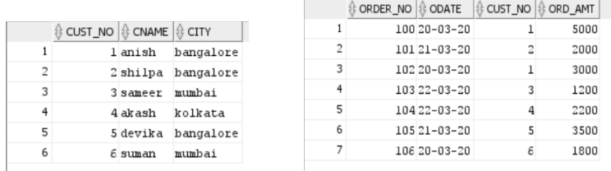

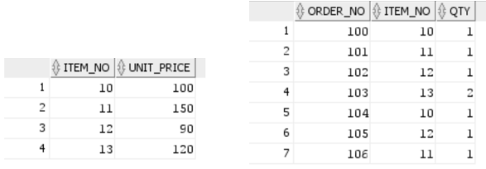Items order_item

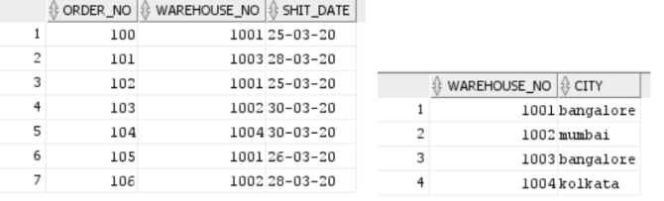 Warehouse shipment

